https://mail.google.com/mail/u/1/images/cleardot.gifBICYCLE THIEF (1948)

*Ladri di biciclette* (*The Bicycle Thief*) is a neorealist film by Vittorio De Sica, considered modern and revolutionary because it radically broke with pre-World War II Hollywood cinematic codes by using real people instead of actors and telling the story of an ordinary man*.* Italian neorealism was a film movement committed to the economic and moral rebuilding of postwar Italy through its portrayal of poverty and injustice; neorealist films were anti-commercial, left-wing, and devoted to the belief that politically committed art could improve society*.* Inspired by Luigi Bartolini’s novel, *Bicycle Thief* tells the story of Antonio Ricci and his son Bruno in postwar Rome. Unable to find employment, Antonio pawns the bed sheets for a bicycle so he can accept a job pasting up publicity posters for movies. After the bike is stolen, he and Bruno spend the entire day searching for it all over Rome. *Bicycle Thief* conforms to the stylistic tenets of neorealism: the use of nonprofessional actors, a rejection of commercial cinematic techniques, simplicity, on-location shooting, and sociopolitical critique. However, as a big-budget film with a cast of hundreds, itupdates the neorealist aesthetic. While *Roma città aperta* (*Rome Open City*, 1945, Roberto Rossellini)*,* the founding neorealist film, focuses on a dramatic subject, *Bicycle Thief* locates drama in everyday situations. De Sica spent six months preparing the script and calculating the realistic filming style. Ultimately, he crafted the illusion of realism and technical poverty, thus providing a significant stylistic shift within the neorealist movement.

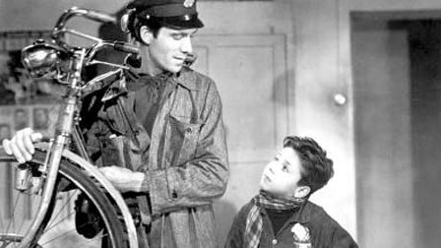

http://www.criterion.com/films/210-bicycle-thieves

References and further reading:

Bingham, A. (2011) ‘Bicycle Thieves’ in Louis Bayman (ed.) *Directory of World Cinema: Italy,* Bristol: Intellect: 61-62.

Marcus, M. (1986) *Italian Film in the Light of Neorealism,* Princeton: Princeton University Press.

Tomasulo F. P. (2000) ‘Bicycle thieves: a Re-reading’ in Howard Curle & Stephen Snyder (eds.) *Vittorio De Sica: Contemporary Perspectives,* Toronto: University of Toronto Press (2000), pp. 160-171.

Wagstaff, C. (2007) *Italian neorealist cinema: an aesthetic approach,* Toronto: University of Toronto Press, pp. 291-401.

Wood, M. P. (2005) *Italian Cinema*. New York: Berg.

Paratextual Material:

*Bicycle Thief* Trailer:

<http://www.mondo-digital.com/bicycle.html>

Photos and Images

<http://www.filmtv.it/film/3831/ladri-di-biciclette/foto/1/>

Italian Neorealism: A History through Film:

<https://www.youtube.com/watch?v=sAhAgyXHC4M>

Maria Alexandra Catrickes  
Yale University